DevOps Assessment – Continuous Integration with GitHub Actions

Name - Prathmesh Singh
CSE D
Roll no - 202401100200235

Github URL: https://github.com/Prathmesh-04/github-skills-challenge

Pull request URL used to validate the workflows:
https://github.com/Prathmesh-04/github-skills-challenge/pulls

Screenshot showing the GitHub Actions workflows

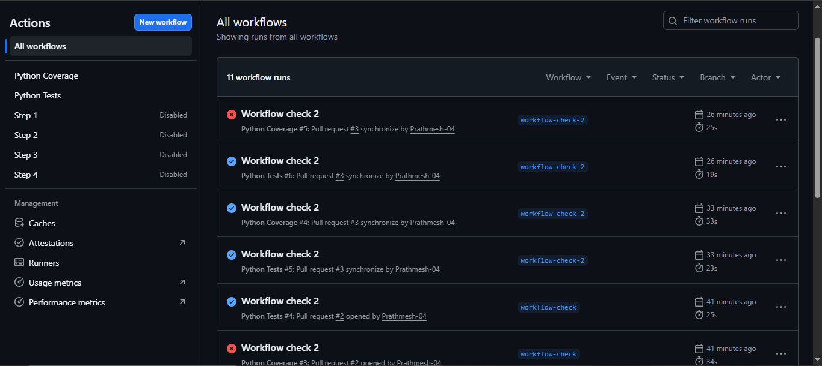

Screenshot showing a successful test workflow execution

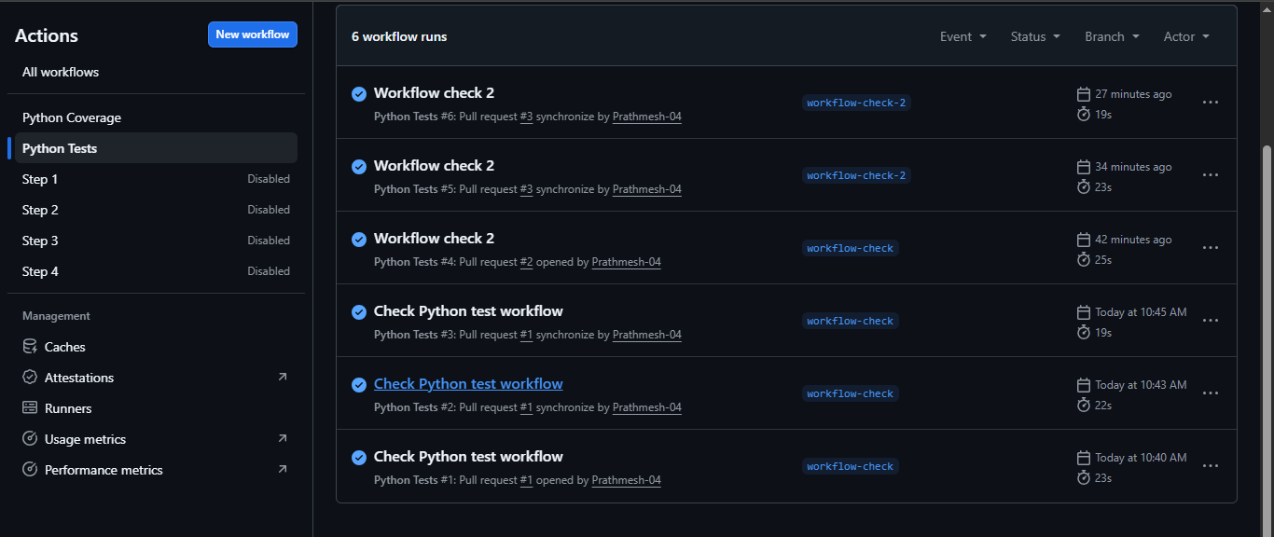

Screenshot showing the coverage result/comment on the pull request

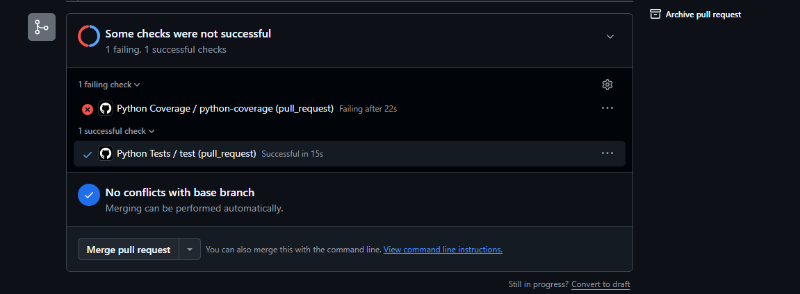
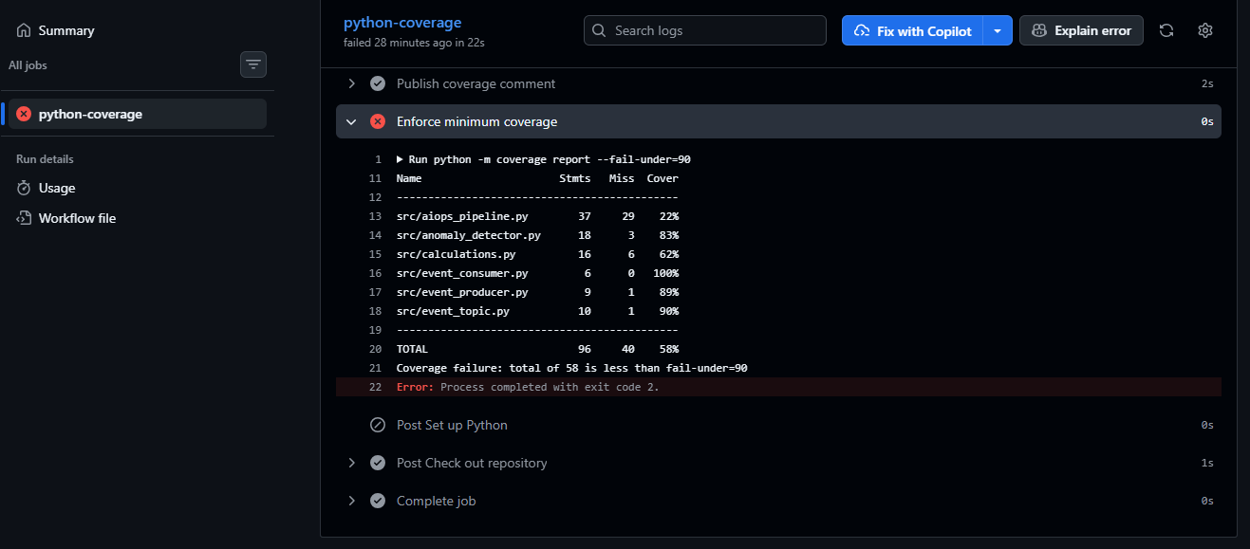

Screenshot showing the final repository/workflow files

